# 8 Camera & Character Movement

|  |  |  |
| --- | --- | --- |
| **NIM** | : | 2118124 |
| **Nama** | : | Alfin |
| **Kelas** | : | D |
| **Asisten Lab** | : | BERCHMANS BAYU BIN JAYA (2218034) |

1. **Membuat character movement**
2. Buka Project Unity sebelumnya

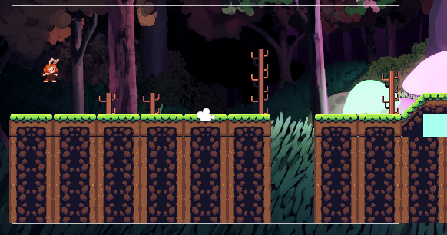

1. Tambahkan komponen Capsule Colider di karakter, lalu klik icon sebelah kanan edit colider.

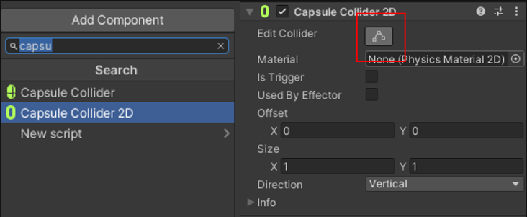

1. Lalu cockan garis oval degan karakternya atau bisa di inputkan Offset X, Y dan juga Size X, Y nya.

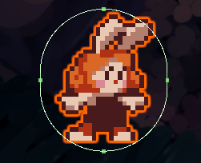

1. Buka Folder project, lalu bikin folder baru bernama Script.



1. Masuk kedalam folder Script, lalu buat C# Script, beri nama Player.



1. Drag & drop script player kedalam Hirarki player-idle-1, lalu klik 2x pada script player maka akan masuk kedalam text editor.

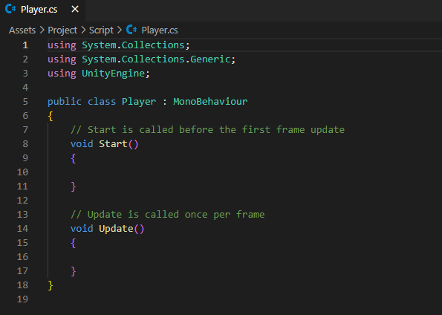

1. Masukan source code dibawah ini, pastikan nama public class harus sama dengan nama file yang dibuat.

|  |
| --- |
| using System.Collections;  using System.Collections.Generic;  using UnityEngine;  public class Player : MonoBehaviour  {  Rigidbody2D rb;  [SerializeField] float speed = 1;  float horizontalValue;  bool facingRight;  private void Awake()  {  rb = GetComponent<Rigidbody2D>();  }  void Update ()  {  horizontalValue = Input.GetAxisRaw("Horizontal");  }  void FixedUpdate()  {  Move(horizontalValue);  }  void Move(float dir)  {  #region gerak kanan kiri  float xVal = dir * speed * 100 * Time.fixedDeltaTime;  Vector2 targetVelocity = new Vector2(xVal, rb.velocity.y);  rb.velocity = targetVelocity;  if (facingRight && dir < 0)  {  // ukuran player  transform.localScale = new Vector3(2, 2, 1);  facingRight = false;  }  else if (!facingRight && dir > 0)  {  // ukuran player  transform.localScale = new Vector3(2, 2, 1);  facingRight = true;  }  #endregion  }  } |

1. Untuk membuat player loncat menggunakan spasi, kita perlu membuat GorundCheck dengan cara, klik Grid pada Hierarchy, pergi ke inspector, pilih Layer, Klik Add Layer.

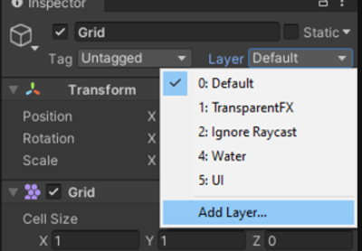

1. Lalu isi “Ground” pada User Layer 6.

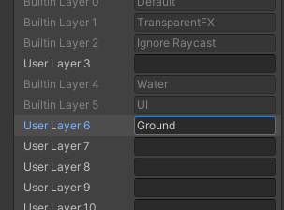

1. Ubah Layer menjadi Ground, jika muncul pop up Change Layer, klik yes saja.

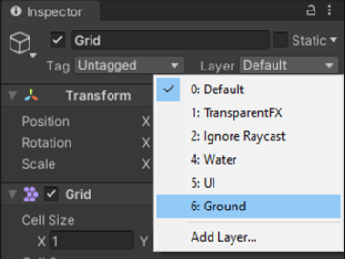

1. Klik kanan pada karakter1, lalu Create empty, beri nama GorundCheck.

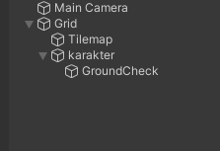

1. Klik pada Hirarki GorundCheck, lalu gunakan “Move Tools” untuk memindahkan ke bagian bawah Player seperti gambar berikut..

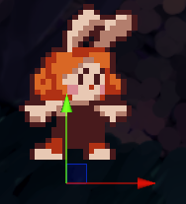

1. Kembali ke script Player tambahkan source code seperti ini.

|  |
| --- |
| [SerializeField] Transform groundcheckCollider;    [SerializeField] LayerMask groundLayer;    const float groundCheckRadius = 0.2f; // +    [SerializeField] float speed = 1;    float horizontalValue;    [SerializeField] bool isGrounded; // +    bool facingRight; |

1. Buat void ground check dibawah void fixedUpdate & tambahkan GorunCheck(); pada void fixedUpdate.

|  |
| --- |
| void FixedUpdate()  {  GroundCheck();  Move(horizontalValue);  }  void GroundCheck()  {  isGrounded = false;  Collider2D[] colliders = Physics2D.OverlapCircleAll(groundcheckCollider.position, groundCheckRadius, groundLayer);  if (colliders.Length > 0)  isGrounded = true;  } |

1. Klik karakter, lalu ke inspector ke effect Player script di bagian “Goruncheck collider” tekan icon lalu pilih yang GorundCheck Transform, dan pada Ground Layer pilih Ground.

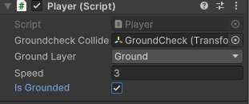

1. Lalu untuk membuat player melompat ubah script menjadi berikut.

|  |
| --- |
| using System.Collections;  using System.Collections.Generic;  using UnityEngine;  public class player : MonoBehaviour  {    Rigidbody2D rb;    [SerializeField] Transform groundcheckCollider;    [SerializeField] LayerMask groundLayer;    const float groundCheckRadius = 0.2f; // +    [SerializeField] float speed = 1;    [SerializeField] float jumpPower = 100;    float horizontalValue;    [SerializeField] bool isGrounded; // +    bool facingRight;    bool jump;      void FixedUpdate()    {    GroundCheck();    Move(horizontalValue, jump);    }    void GroundCheck()    {      isGrounded = false;      Collider2D[] colliders = Physics2D.OverlapCircleAll(groundcheckCollider.position, groundCheckRadius, groundLayer);      if (colliders.Length > 0)      isGrounded = true;    }    private void Awake()    {      rb = GetComponent<Rigidbody2D>();    }    void Update ()    {      horizontalValue = Input.GetAxisRaw("Horizontal");      if (Input.GetButtonDown("Jump"))          jump = true;      else if (Input.GetButtonUp("Jump"))          jump = false;    }    void Move(float dir, bool jumpflag)    {      #region gerak kanan kiri      float xVal = dir * speed * 100 * Time.fixedDeltaTime;      Vector2 targetVelocity = new Vector2(xVal, rb.velocity.y);      rb.velocity = targetVelocity;      if (facingRight && dir < 0)      {        // ukuran player        transform.localScale = new Vector3(-4, 4, 4);        facingRight = false;      }      else if (!facingRight && dir > 0)      {        // ukuran player        transform.localScale = new Vector3(4, 4, 4);        facingRight = true;      }      if(isGrounded && jumpflag)      {          isGrounded = false;          jumpflag = false;          rb.AddForce(new Vector2(2f, jumpPower));      }      #endregion    }  } |

1. Buat folder baru di project bernama “Physics”. Didalam folder Pyshics create > 2d > physical material 2d , berinama “Player”.

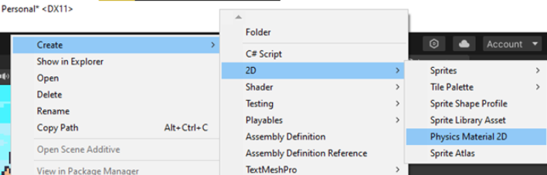

1. Klik Player (Physics Material 2D), dibagian menu inspector, friction & bounces ubah menjadi 0.

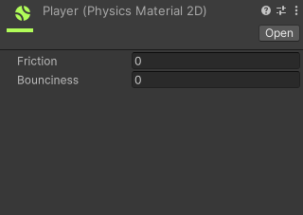

1. Klik Hierarchy pilih karakter, pada Inspector Cari Rigidbody 2D lalu klik icon untuk membuka box select physhics material 2d , lalu pilih asset Player yang sudah kita buat tadi.

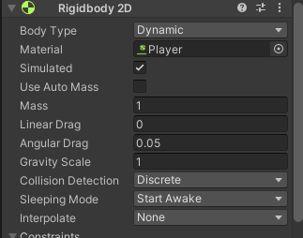

1. Tekan play, maka player bisa melompat dengan menekan spasi.

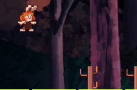

1. **Membuat Camera Movement**
2. Create Empty pada Hirarki, dan Rename Menjadi Camera

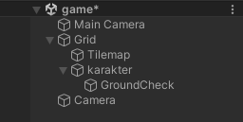

1. Sesuaikan Setting Layer Camera seperti gambar dibawah ini

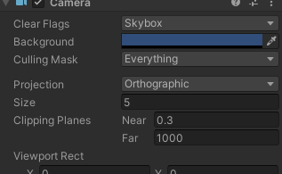

1. Buat file script baru di folder Script dengan nama ”CameraFollow”, Lalu tuliskan script berikut ini. Drag & drop script CameraFollow Kedalam Layer Camera.

|  |
| --- |
| using System.Collections;  using System.Collections.Generic;  using UnityEngine;  public class CameraFollow : MonoBehaviour  {  public float xMargin = 0.5f;  public float yMargin = 0.5f;  public float xSmooth = 4f;  public float ySmooth = 4f;  public Vector2 maxXAndY;  public Vector2 minXAndY;  private Transform player;  void Awake()  {  player = GameObject.FindGameObjectWithTag("Player").transform;  }  bool CheckXMargin()  {  return Mathf.Abs(transform.position.x - player.position.x) > xMargin;  }  bool CheckYMargin()  {  return Mathf.Abs(transform.position.y - player.position.y) > yMargin;  }  void FixedUpdate()  {  TrackPlayer();  }  void TrackPlayer()  {  float targetX = transform.position.x;  float targetY = transform.position.y;  if (CheckXMargin())  targetX = Mathf.Lerp(transform.position.x, player.position.x,  xSmooth * Time.deltaTime);  if (CheckYMargin())  targetY = Mathf.Lerp(transform.position.y, player.position.y,  ySmooth * Time.deltaTime);  targetX = Mathf.Clamp(targetX, minXAndY.x, maxXAndY.x); targetY =  Mathf.Clamp(targetY, minXAndY.y, maxXAndY.y); transform.position = new  Vector3(targetX, targetY, transform.position.z);  }  } |

1. Lalu klik pada camera, buka inspector Pada bagian Camera Follow (Script) Ubah Bagian Max X dan Max Y nya

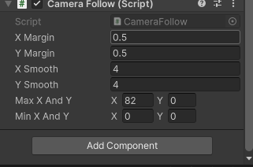

1. Ubah tag di karakter Untagged menjadi ”Player”

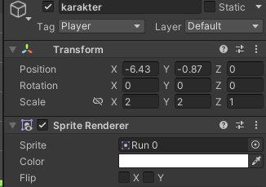

1. **Kuis**
2. Jelaskan source code berikut

|  |
| --- |
| using System.Collections;  using System.Collections.Generic;  using UnityEngine;  public class CameraFollow : MonoBehaviour  {  [SerializeField] private Transform player;  void update (){  transform.position = new Vector3 (player. position.x, transform.position.y, transform.position.z);  }} |

Penjelasan

Script ini dalam Unity, ditulis dalam C#, membuat kamera mengikuti pemain. Kelas `CameraFollow` memiliki variabel `player` yang ditandai dengan `[SerializeField]` agar dapat diatur melalui Unity Editor. Dalam metode `Update`, posisi kamera diatur ulang setiap frame untuk mengikuti posisi horizontal pemain. Ketinggian dan kedalaman kamera tetap konstan. Dengan demikian, kamera selalu fokus pada pemain saat bergerak ke kiri atau kanan.